Name :- Piyush Sunil Patil
Roll No :- 143
Assigment NO :- 02
Assigment Name :- Clone the repository at
https://github.com/piyushpatil/KBCNMU

admin@DESKTOP-K3MVO4B MINGW64 ~
$ git --versionn
unknown option: --versionn
usage: git [-v | --version] [-h | --help] [-C <path>] [-c <name>=<value>]
[--exec-path[=<path>]] [--html-path] [--man-path] [--info-path]
[-p | --paginate | -P | --no-pager] [--no-replace-objects] [--bare]
[--git-dir=<path>] [--work-tree=<path>] [--namespace=<name>]
[--config-env=<name>=<envvar>] <command> [<args>]

admin@DESKTOP-K3MVO4B MINGW64 ~
$ git --version
git version 2.40.0.windows.1

admin@DESKTOP-K3MVO4B MINGW64 ~
$ git --help
usage: git [-v | --version] [-h | --help] [-C <path>] [-c <name>=<value>]
[--exec-path[=<path>]] [--html-path] [--man-path] [--info-path]
[-p | --paginate | -P | --no-pager] [--no-replace-objects] [--bare]
[--git-dir=<path>] [--work-tree=<path>] [--namespace=<name>]
[--config-env=<name>=<envvar>] <command> [<args>]

These are common Git commands used in various situations:

start a working area (see also: git help tutorial)
clone Clone a repository into a new directory
init Create an empty Git repository or reinitialize an existing one

work on the current change (see also: git help everyday)
add Add file contents to the index
mv Move or rename a file, a directory, or a symlink
restore Restore working tree files
rm Remove files from the working tree and from the index

examine the history and state (see also: git help revisions)
bisect Use binary search to find the commit that introduced a bug
diff Show changes between commits, commit and working tree, etc
grep Print lines matching a pattern
log Show commit logs
show Show various types of objects
status Show the working tree status

grow, mark and tweak your common history
branch List, create, or delete branches
commit Record changes to the repository
merge Join two or more development histories together
rebase Reapply commits on top of another base tip
reset Reset current HEAD to the specified state
switch Switch branches
tag Create, list, delete or verify a tag object signed with GPG

collaborate (see also: git help workflows)
fetch Download objects and refs from another repository
pull Fetch from and integrate with another repository or a local branch
push Update remote refs along with associated objects

'git help -a' and 'git help -g' list available subcommands and some
concept guides. See 'git help <command>' or 'git help <concept>'
to read about a specific subcommand or concept.
See 'git help git' for an overview of the system.

admin@DESKTOP-K3MVO4B MINGW64 ~
$ git clone https://github.com/NileshNarkhede2002/KBCNMU.git
Cloning into 'KBCNMU'...
remote: Enumerating objects: 3, done.
remote: Counting objects: 100% (3/3), done.
remote: Total 3 (delta 0), reused 0 (delta 0), pack-reused 0
Receiving objects: 100% (3/3), done.

1.Create Repositories

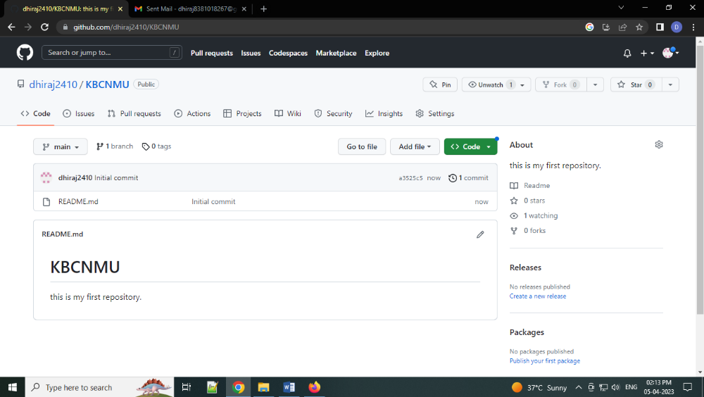

2.After cloning
